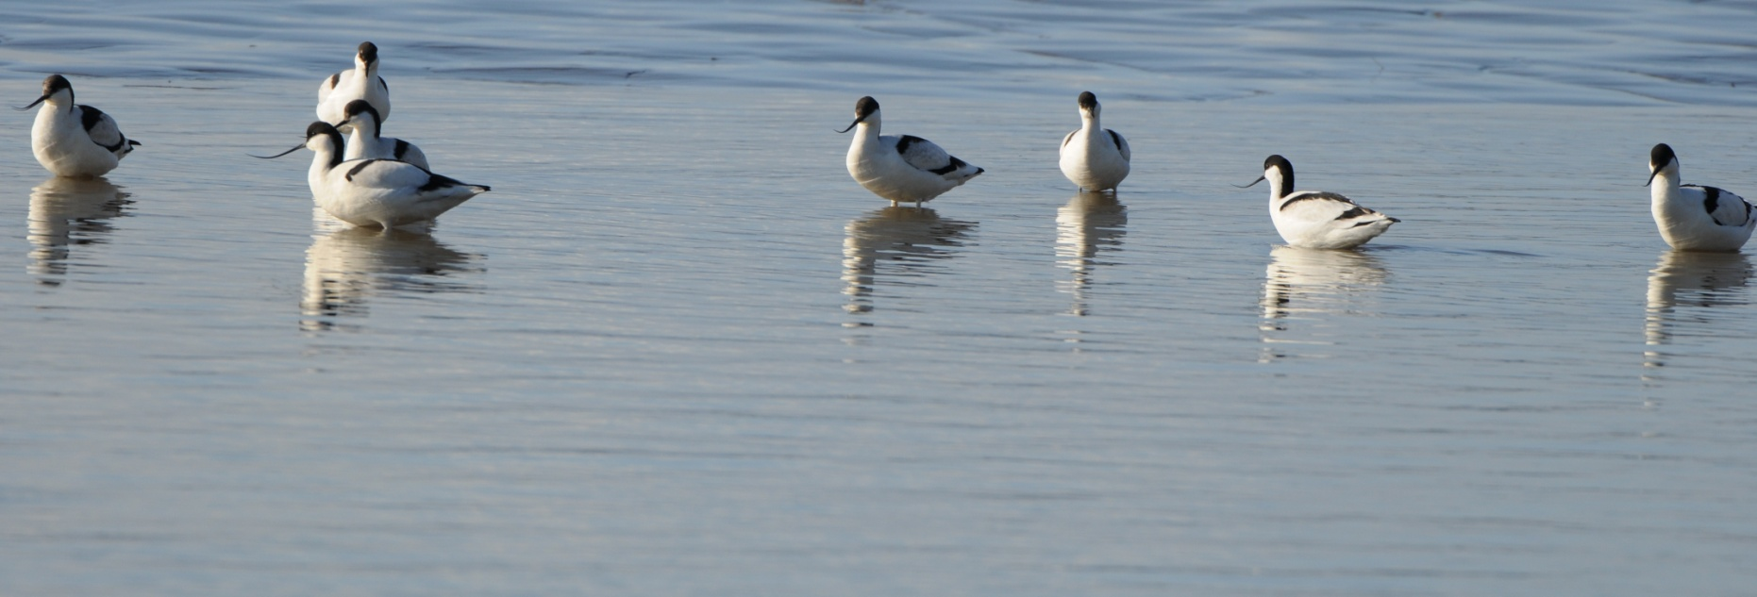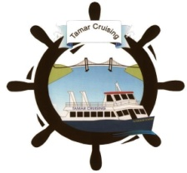

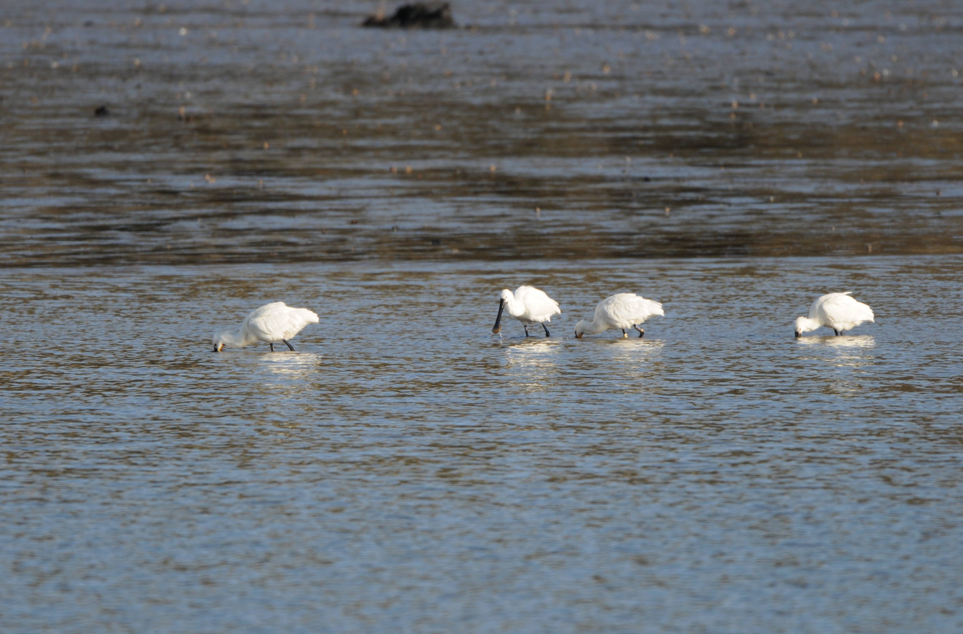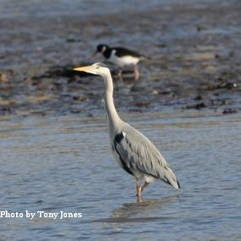

**Tickets from Bruce Taggart  01752 829163**

**email tamarwildlife@btinternet.com**

**www. tamarwildlife.co.uk**

Tamar Wildlife Primrose Bank Radford Lane Millbrook Cornwall PL10 1AH

**Winter 2011/ 2012 sailing dates and times**

Join us for a 3 hour cruise on the beautiful River Tamar and River Lynher

* Large open upper deck and comfortable enclosed cabin.
* Full commentary by leading ornithologist Bruce Taggart.
* RSPB staff and local experts are on the boat offering help and advice.
* Hot refreshments, bar and

toilets on board.

**Cremyll Quay Saltash Town Quay**

**Thursday 10th November 10.45am 11.15am**

**Saturday 10th December 10.45am 11.15am**

**Sunday 19th February 09.30am 10.00am**

**Tamar Birdwatching Cruises**

**Adults £15.00 Children £7.00**

**Advanced Booking**

**Essential**