BACK FROM THE BRINK
A HISTORY OF THE CIRL BUNTING IN CORNWALL.
PART 2 21st Century, the first 10 years.
In the last issue of Palores the history of the Cirl bunting in Cornwall was discussed up until 1999. With the turn of the millennium the fortunes of this often secretive bunting were about to change. This article describes the recovery of the population due to the efforts of the reintroduction programme in south Cornwall.
From 2000 until 2006 the number of Cornish records was still minimal. It is possible that one or two pairs remained undetected but there were no confirmed breeding records. Table 1 lists all records.
Table 1 Cirl Buntings in Cornwall 2000 -2006
Year | 10Km square | Records
2000 | SW 72 | A report of 6-8 birds at Maenporth Bay on 20 Oct [RSPB]was not recorded in Birds in Cornwall
2001 | SW 83 | At least 2 females reported at Trevennel Farm on 16 Mar [RSPB] but BiC lists no confirmed records
2002 | SX44 | A pair at Rame Head 21 – 23 Mar with male on 21 Apr and 4 Jul
2003 | SX44 | Single birds at Rame Head Church on 2 Aug and Penlee Battery on 10 Nov
2004 | SX44 | One at Rame on 2 Nov
2005 |  | No records received
2006 | SX44 | An encouraging series of reports from Rame with a male and 5 females on 8 Jan, 6 females on 9 Mar and a pr on 1st Apr. Although there was no proof of breeding, 3 females/imm were seen on 18 and 26 Oct and four females on 23 Nov.

In contrast to the situation in Cornwall, the Devon population was undergoing a renaissance. From a low of 114 territories in 1989 the population had risen to 450 in 1998 and almost 700 pairs by 2003. This was largely due to a concerted effort by the RSPB and English Nature [now Natural England] to encourage farmers to participate in agri-environment schemes which enhanced farmland biodiversity. Peach et al [2001] showed that Cirl Buntings increased by 82% on land entering Countryside Stewardship agreements but by only 2% on adjacent land not managed in this way.
However the population increase was not matched with an increased range. Cirl buntings, being generally sedentary, were infilling in suitable habitat along the coastal belt between Plymouth and Exeter and slowly spreading inland, but the expansion was slow. As part of the Biodiversity Action Plan, re-introduction was considered to speed up this process and provide a buffer, should anything happen to the isolated Devon population.
In 2003 and 2004, the RSPB surveyed the two areas in Cornwall where birds had been most frequently seen; the Rame Head area and the Roseland Peninsula, with a view to a future re-introduction programme.
Rame was only 6 Km from the nearest breeding population in the Wembury/Bovisand area and it is from here that natural recolonisation might occur. However the coastal strip between Rame and Penlee was largely ungrazed and the resulting dense blackthorn scrub was making this area increasingly unsuitable for Cirl Bunting.
On the Roseland Peninsula, although no Cirl Buntings were found on Countryside Stewardship managed land, there was an extremely rich arable flora and good numbers of other farmland birds which suggested that the area was very important for declining farmland wildlife. There was also potential to build on the existing habitat and create extensive areas of low input, biodiversity- rich mixed farmland, thus facilitating population expansion.
In 2004, a partnership between the RSPB, Natural England, the National Trust and Paignton Zoo embarked on a trial project, hand rearing and releasing chicks in Devon. Subsequent monitoring proved that some of these birds survived, integrated with the wild population and bred in 2005 illustrating that the method was successful. [Two of the pilot birds survived into 2008 which was a new British longevity record for Cirl Bunting].
Consequently, a four-year project began in Cornwall in 2006 with 75 chicks taken under licence from 22 nests in Devon and taken to Cornwall where they were hand reared by two dedicated aviculturalists employed by Paignton Zoo. The chicks are taken when 6-7 days old. [A whole brood is removed which will then allow the targeted pair to re-lay and hopefully rear another brood]. They are ringed with a unique colour combination allowing them to be identified individually and initially placed in heated brooders which imitate conditions in the nest. When 12-14 days old, the fledglings are moved to small ‘canary’ cages where they can perch and flap, developing their wing muscles and begin feeding themselves. At about 20 days old they begin to assume an inherent fear of humans and are taken to secluded outdoor aviaries at the release site nearby. Here they remain for another week or so gradually becoming accustomed to their surroundings and familiarising themselves with the immediate area before being freed - a technique known as ‘soft release’.
The hand rearing has generally been highly successful. The mortality in 2007 was primarily due to an outbreak of the infection Campylerbacter but subsequent increased bio-security measures have eliminated any re-occurrence. Table 2 summarises the number of released birds since 2006.
Table 2
Year | No of chicks taken | No of chicks released
2006 | 75 | 72
2007 | 75 | 47
2008 | 75 | 68
2009 | 80 | 67

The ringed population of released birds has been comprehensively monitored. This has enabled yearly survival and dispersal to be examined. As expected all birds have remained with 3 Km of the release site and most within 2 Km. Pairs remain faithful from one year to the next providing both have survived, but will readily repair if one adult dies.
In 2007 the first proven breeding since 1994 was recorded. Away from the reintroduction site, one was seen at Rame on 1 Nov.
Table 3 illustrates the progress of the reintroduced populationto date. All figures are minimum numbers
Table 3
Year | No of pairs/females | No of pairs breeding | No of breeding attempts | No of chicks hatched | No of chicks fledged
2007 | 9 | 7 | 12 | 23 | 11
2008 | 12 | 11 | 20 | 45 | 15
2009 | 13 | 13 | 24 | 54 | 42

The population was not helped by the weather in 2007 and 2008. Along with several other species, Cirl Buntings productivity is poor in cool, wet summers. This is maybe due to the adults not being in prime breeding condition, a reduction in invertebrate prey available for the chicks and harder to find, the female needing to spend more time brooding and less time foraging and poor post fledging survival. It is probably a combination of all these factors. It must be remembered also that in 2007 it was a young population, all first year birds. Monitoring has shown that more experienced birds are far more successful in raising their broods.
In 2008, the increase in the number of breeding attempts and chicks hatched was notable but again with poor fledging success, again primarily due to wet weather. In addition to the released birds an encouraging number of sightings at a site in south-east Cornwall led to speculation that breeding may have occurred. Reports included a pair in March, a single male in July and up to two males and 2 females in Oct.
Last year was much more successful even though the predicted ‘Bar-B-Q summer didn’t materialise! Compared with 2007, although there was only twice as many breeding attempts the productivity was four times higher. The introduction of supplementary feeding of mealworms during wet periods may have contributed to this. These were supplied near the nest site and were quickly accepted by the adults as a food source for hungry chicks. [see photo].The provision of feeding stations post fledging, also aided survival during this critical period. When added to the 67 introduced birds, there were over 100 new recruits into the population. Interestingly in 2009 there were several instances of polygamy; one was noted where a male sired young with 3 separate females. BWP records two instances of a male with 2 females but three is unprecedented.
In south-east Cornwall a pair was present at one site and a singing male at a second.
During the autumn the birds move into barley stubble fields, or Stewardship areas sown with a wild bird seed mix. The importance of overwintering barley stubble cannot be overstated, not only for Cirl Buntings but for a whole range of farmland birds. This is just one of a suite of options available to farmers under Higher Level Stewardship and it is encouraging to see more and more farmers wishing to become involved.
The severe weather experienced by the rest of the country was luckily not mirrored in south Cornwall and overwinter survival is looking good. It is difficult though to assess the exact numbers as the population now contains unringed wild-bred birds. It is estimated that a self sustaining population needs at least 35 pairs and projections indicate this could be achieved within the next 2 years. Together with the natural re-colonisation of an additional pair in south east Cornwall in 2008, and possibly 2 territories in 2009, the future of Cirl Buntings in Cornwall is looking very positive.
The next two years are critical but with the support of the project partners, the farming community and a band of willing staff and volunteers it is hoped that this enigmatic little bird has well and truly been brought “back from the brink”.
All reports of Cirl buntings should be forwarded to the County Recorder and to Nick Tomalin, RSPB Cirl Bunting Project Officer, tel 07702 779345, email nick.tomalin@rspb.org
Anyone wishing to commit to regular voluntary monitoring work should also contact Nick.
Bruce Taggart and Nick Tomalin,
Cirl Bunting Re-introduction Project Officers
References
Evans, A D (1997), Cirl Buntings in Britain. Br. Birds, 90
Jeffs C and Locke L (2004) Cirl Buntings in Cornwall 2003. RSPB, Sandy
Peach W J et al (2001), Countryside Stewardship delivers Cirl Buntings in Devon. Bio. Cons.101.
Penhallurick R C (1978) The Birds of Cornwall and the Isles of Scilly. Headland, Penzance
Rodd E H (1880), The Birds of Cornwall and the Isles of Scilly
Sharrock J T R (1976) The Atlas of Breeding Birds in Britain and Ireland BTO/Poyser
Sitters H P (1985) Cirl Buntings in Britain 1982. Bird Study 31
Stevens D K et al (2002), Territorry distribution and foraging patterns of Cirl Buntings breeding in the UK. Bio.Cons 107.
Various eds,(1935-2006) Birds in Cornwall, annual reports of CBWPS.
Walpole-Bond J (1938), A History of Sussex Birds, 3 vols, London.
Wingfield Gibbons et al(1993), The New Atlas of Breeding Birds in Britain and Ireland Poyser London
Wotton S R et al (2000), The status of the Cirl Bunting in the UK. Bird Study 47.

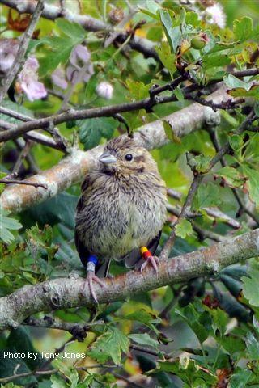
Juvenile Cirl Bunting in Cornwall (photo Tony Jones)

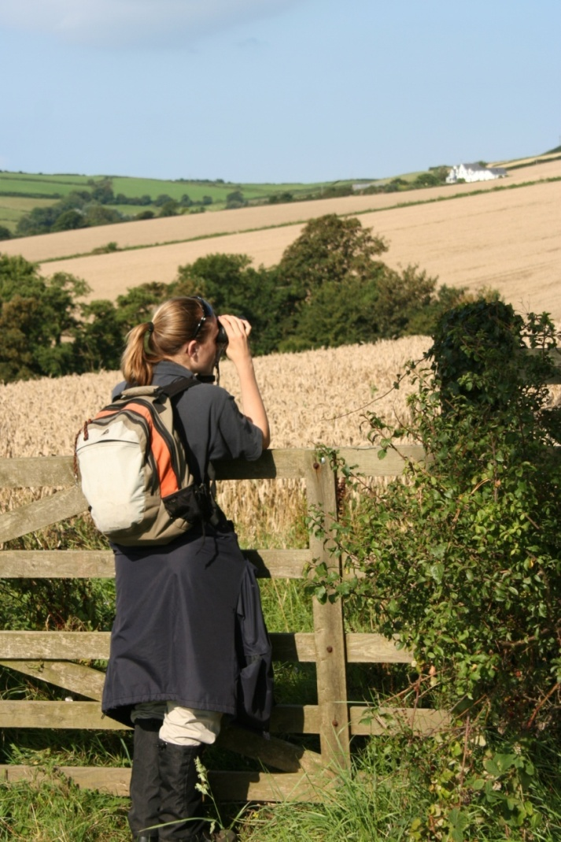
Monitoring Cirl Buntings - photo Bruce Taggart
Feeding Time! (photo Bruce Taggart)

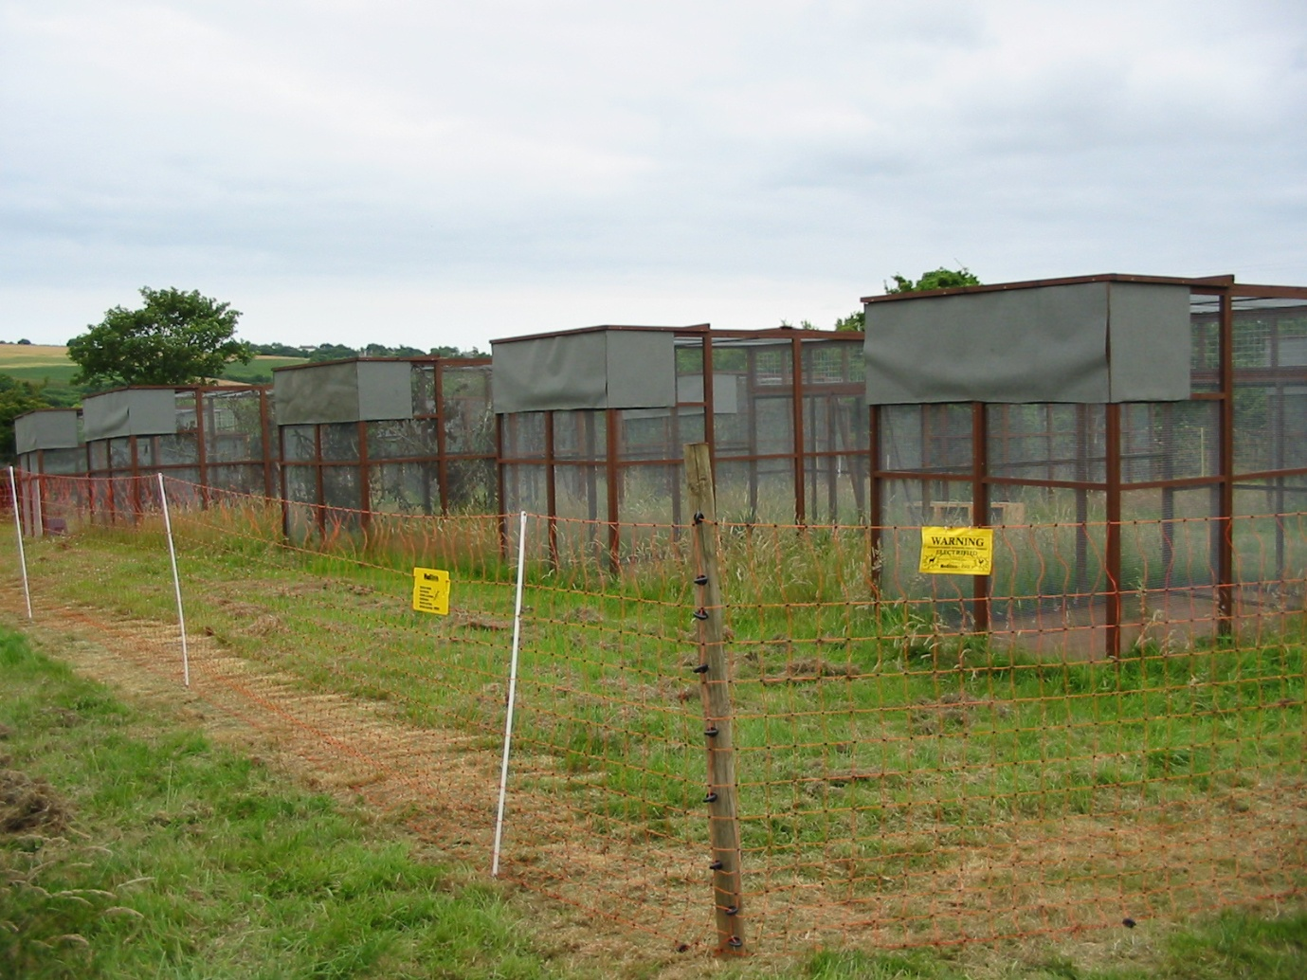
Avaries at release site with electric fencing to exclude predators (photo Bruce Taggart)
Juvenile Cirl Bunting prior to release (photo Bruce Taggart)