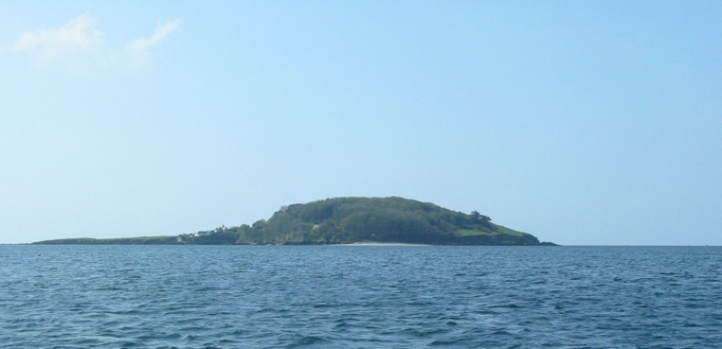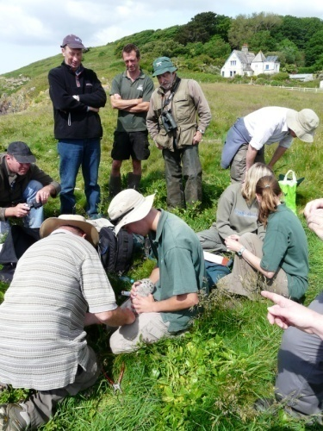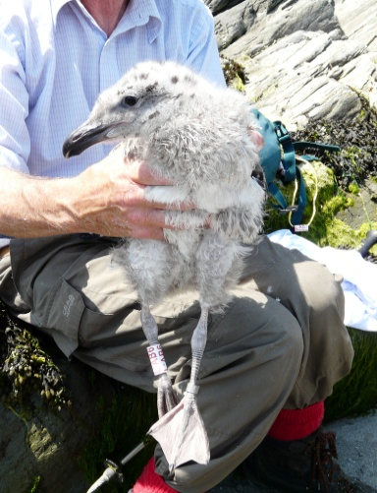

***News***

*Welcome to the first edition of the SGIGRP newsletter which I hope to produce three time per year to keep everyone updated with the project.*

Following two visits in May, 78 GBB nests were counted with 218 eggs. (I thought we were going to be in for a big year and ordered some more rings!) Ringing started in June when a team of ten volunteers visited the Island on two occasions. We caught forty nine chicks and fitted a BTO ring on the left leg and a white plastic ring engraved with red identification codes on the right. This was far fewer than I expected. Is this normal for a long lived bird? Is there predation at the egg or chick stage? Is chick mortality related to food supply?....so many questions. Cannibalism?!! I’m looking into the possibility of obtaining funding for further research to find out what is going on.

However, the scheme has now begun to pay dividends. In August, shortly after fledging 6 juveniles were sighted at Looe. and in early September another two were seen at Downderry.

The first foreign report was L:AJ1, seen on Omaha Beach, Vierville sur Mer, France, 81 days after ringing and 275 km from St Georges Island.

Three days later L:AK6 was reported from Parelle Beach in Guernsey. Interestingly a Guernsey ringed Great Black back was seen at Downderry on 20th September so maybe these birds crossed mid Channel!!

*Thanks to everyone who has sent in reports.*

***Sightings***

*VV=Ring read in the field*

*X=found dead*

L:AA2 13/06/2010[MSW]

*X* St Georges Island 10/07/10

LAA3 13/06/2010[MSW]

*VV* Looe Beach 18/08/10

L:AB1 27/06/2010[MSW]

*VV* Looe Beach 21/08/2010

L:AB6 13.06.2010[BT]

*VV* Looe Beach 25/08/10

L:AH0 27.06.2010[BT]

*VV* Looe Beach 21/8/10

L:AJ1 27.06.2010[BT]

*VV* Omaha Beach, Vierville sur mer, France.

L:AJ3 27.06.2010[BT]

*VV* Downderry Beach, 1/09/10 & 7/9/10

L:AJ4 27/06/2010[BT]

*VV* Looe 28/08/10

L:AJ5 27/06/2010[JW]

*X* St Georges Island 13/08/10

L:AK3 27/06/2010[JW]

*VV* Looe Beach 25/08/10

L:AK4 27/06/2010[BT]

*VV* Downderry Beach 06/09/10

L:AK6 27/06/2010[BT]

*VV* Parelle Beach, Guernsey 19/09/10 & 17/10/10

*VV* L’Eree Beach Guernsey

21 & 24/09/10

Photos St Georges Island; the ringing team; L:AB1; Gulls on Parelle Beach, Guernsey; L:AK6 L’Eree Beach Guernsey 21/09/2010 [Paul Veron]

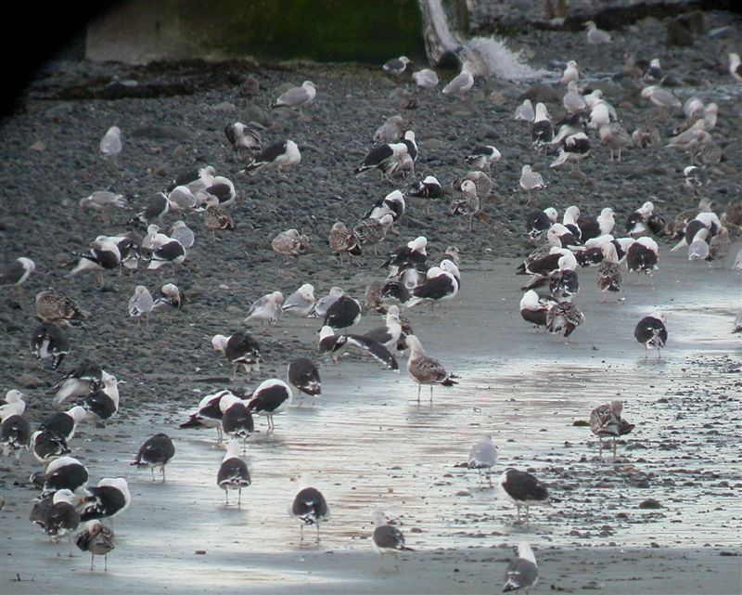

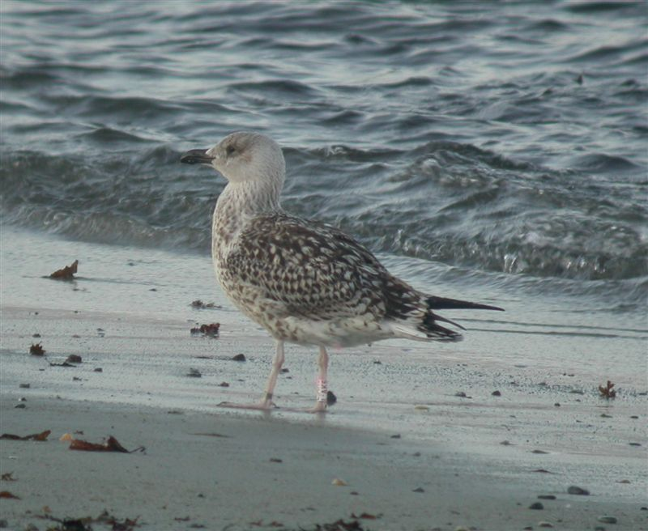

*St Georges Island Gull Ringing Project*

[looegulls@gmail.com](mailto:looegulls@gmail.com).

*E-Newsletter Number 1 October 2010*