**Spoonbills Tamar December 2009**

On the Dec. 13th Tamar cruise a Spoonbill was observed with the following colour rings.

Left Leg- light green over yellow over light green  
Right leg- Red over yellow flag over metal.

Otto Overdijk of the Dutch Spoonbill Workng Group replied to the request for information with the following news:

Indeed, now I can identify this bird. A juvenile bird ringed at Den Oever 29/7/2009 ( just North from Amsterdam, Wadden Sea Coast Lat 52.934N Lon 5.031E )

This is a new breeding site in Netherlands situated at a dike. See photo below. This dike has no connexion with the mainland. It's a dike to slow-down the current. That it has no connexion with land means also that birds are safe, there are no foxes or other ground predators. Also no people come and set feet onto this dike so it also very quiet for Spoonbills.

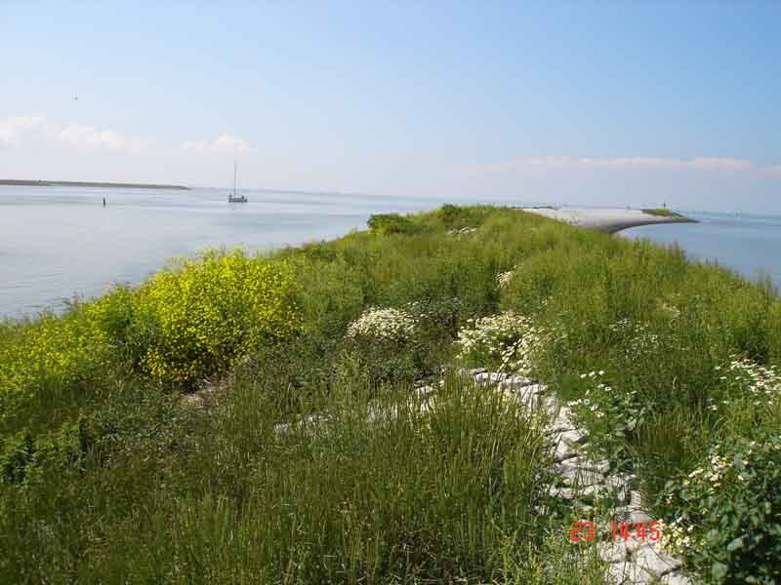

 Working group Spoonbills International

 species: Eurasian Spoonbill (Platalea leucorodia leucorodia)            7325/106859  
 colour rings : LYL/RYfa       ringing place: NL  Den Oever, Banaan 52 56N-05 02E  
 metal ring nr : NLA .8050697    ringing age : nestling  
 ringing date: 29-07-09               sex : unknown

 date    country and site or reserve                 observer            days   dist sexe

16-09-09 NL  Den Oever           nabij haven         Leon Kelder            49    0 km.    
24-09-09 NL  Den Oever           nabij haven    Leon Kelder            57    0 km.    
15-11-09 GB  Cornwall Plymouth   River Lynher     Bruce Taggart   109  696 km.    
13-12-09 GB  Cornwall Plymouth   River Lynher     Bruce Taggart   137  696 km.

**See the Dutch Spoonbill Working Group and follow some of the birds in Google earth!.** [**www.werkgroeplepelaar.nl**](http://www.werkgroeplepelaar.nl/)

**Please report all colour ringed Spoonbill sightings to Otto Overdijk at** [**o.overdijk@wxs.nl**](mailto:o.overdijk@nauurmonumenten.nl)